Particle Workshop V1.0.

Let’s make this show magical.

*Through particles. I’m not a magician. I can’t teach you that.*

Welcome to the beginning area of the workshop. Right now, you probably already had the presentation. If this is not the case, then you’re probably some sort of hacker. That’s cool, I respect that. During the presentation you gained info about a Pong game, and thought about how the particle system itself could work. Here, we’ll put that knowledge to work.

To begin with, implement the particle system. This can be done within the Starting Framework to ensure that there will be no distractions. Within this framework a couple of classes have already been set up for you – don’t worry about them. They solely exist to ensure that all your focus is on the particles and their emitter.

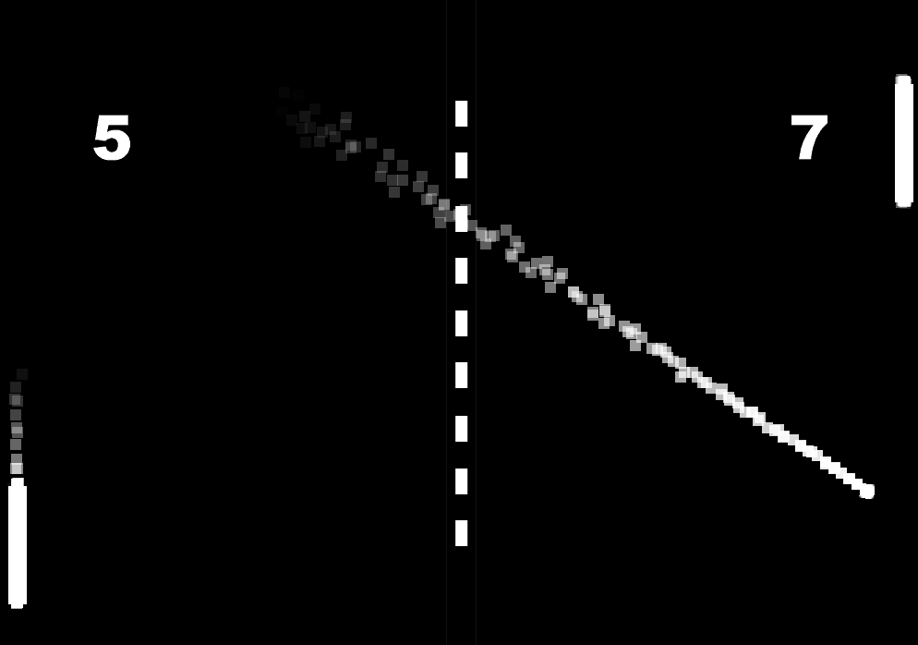Once you have the particle system up & running, it will be about time to implement it. This can be done within the Pong game. Copy over the two classes that you’ve used for the particle system and try to accomplish the following:

Take note of the trailing effect of the pong ball, and the trailing effects of the paddles.

If you get stuck at any point during this workshop, feel free to ask questions!

Link to the presentation: <https://prezi.com/ljivokoyx6n8/particle-workshop-v10/>